Tab 1
You can also include the logos of other institutions/organisations (if relevant)
(please delete the above line)

Research Advert / Flyer / Poster

If space is restricted and you can’t include the logos, ensure you clarify that this is Monash research when you provide the details below.
- Briefly explain the aim of the study, what the participants will be asked to do, and how much time it will take.
- Briefly explain who the target participants are and include any exclusion criteria.
- Insert graphics (if applicable).
- Include a Link to Explanatory Statement.
- Include a contact from the research team for queries and further information.
- Include the MUHREC project ID (copy from ERM, top right corner) and title.

Working Copy

Project ID: 53838
Project title: Investigating a multi-agent AI governance and ethics training platform

When AI Agents Disagree, Who Do You Trust?

This study explores how AI advice shapes ethical decision-making. You will work through a series of engineering ethics scenarios: make an initial decision, see advice from a panel of AI agents (who may or may not agree with each other), then decide whether to keep or change your answer. Takes approximately 10-15 minutes, completed online.
Open to current engineering industry employees or students (undergraduate or postgraduate), aged 18+.
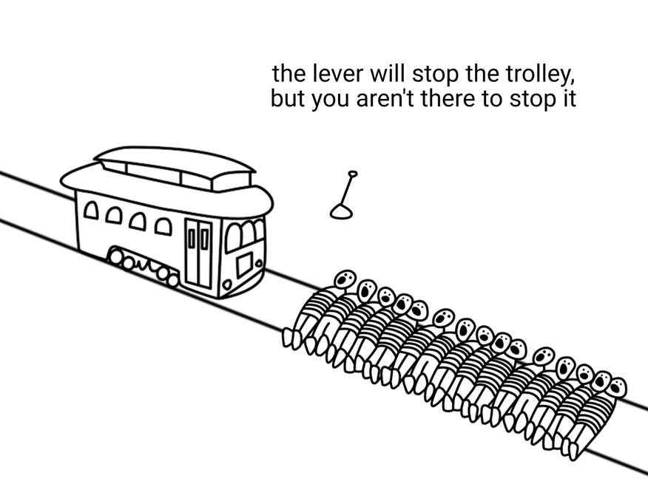
- For full details about what participation involves, see the [INSERT LINK]
- Questions? Contact our team:
  - Aryan Cyrus - amaj0006@student.monash.edu
  - Ubaid Irfan - uirf0001@student.monash.edu
  - Supervisor, ABM Russel at at abm.russel@monash.edu

[INSERT LARGE VISIBLE QR CODE?]

